Project: Motswana Auto Electrical – Enterprise Network Design
Prepared By: Musa Prince Sithoza
Student Number: 45500207
Location: Taung
Course/Module: CMPG 325
Date: 28 August 2026
1. Client Requirements
Motswana Auto Electrical, located in Taung, needs a reliable and secure network to connect three main departments: Admin, Workshop, and Sales.
The network must meet the following requirements:
- Connectivity: The three departments must be able to communicate with each other. The Main Router will manage this traffic.
- IP Phones: Each department needs IP phones for internal voice communication.
- Central Server: The Admin department will host a central server for files and shared services.
- Printing: Each department needs a network printer.
- Security: The network must be segmented into separate VLANs to keep departments isolated and secure.
- Growth: The IP addressing plan must allow for new devices to be added in the future without reconfiguring the whole network.
- WAN Links: The network must use serial connections between the Main Router and the department routers to simulate a multi-site setup.

2. Physical Topology
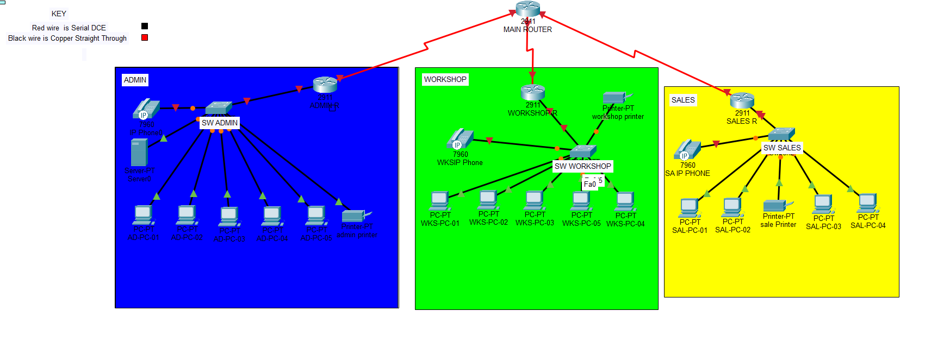
Physical Design Overview:
The physical layout uses a Star (Hub-and-Spoke) topology. The central Main Router (Cisco 2911) acts as the hub. It connects to the Admin, Workshop, and Sales routers using Serial DCE cables.
Inside each department, a Cisco 2960 switch connects all the PCs, IP phones, and printers using Copper Straight-Through cables. This setup is easy to troubleshoot because if one department goes down, the others stay online.
3. Logical Topology
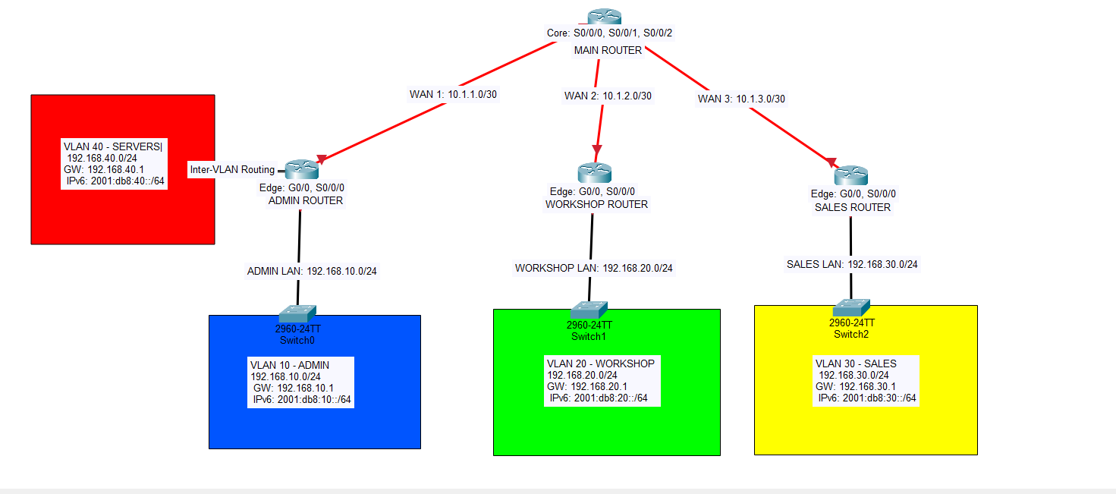
Logical Design Overview:
The logical map shows how the network is divided into separate broadcast domains. Each departmental router is the default gateway for its own network.
The network is divided into four VLANs to keep traffic organized and secure:
- VLAN 10 (Admin): For the Admin office PCs.
- VLAN 20 (Workshop): For the Workshop department PCs.
- VLAN 30 (Sales): For the Sales department PCs.
- VLAN 40 (Servers): For the central server. This is isolated to protect company data.

4. IP Addressing Plan
The IP plan uses private addresses. I used a /30 mask for the WAN links because they only need two IP addresses. I used a /24 mask for the LANs to allow plenty of room for future devices.
Netwok Name | VLAN ID | Subnet Address | Usable Host Range | Default Gateway | Interface
ADMIN LAN | 10 | 192.168.10.0/24 | 192.168.10.1 - .254 | 192.168.10.1 | Admin R G0/0
WORKSHOP LAN | 20 | 192.168.20.0/24 | 192.168.20.1 - .254 | 192.168.20.1 | Workshop R G0/0
SALES LAN | 30 | 192.168.30.0/24 | 192.168.30.1 - .254 | 192.168.30.1 | Sales R G0/0
SERVERS | 40 | 192.168.40.0/24 | 192.168.40.1 - .254 | 192.168.40.1 | Admin R G0/0.40
WAN Link 1 | N/A | 10.1.1.0/30 | 10.1.1.1 - .2 | N/A | Main S0/0/0 <-> Admin S0/0/0
WAN Link 2 | N/A | 10.1.2.0/30 | 10.1.2.1 - .2 | N/A | Main S0/0/1 <-> Workshop S0/0/0
WAN Link3 | N/A | 10.1.3.0/30 | 10.1.3.1 - .2 | N/A | Main S0/0/2 <-> Sales S0/0/0

5. Design Justification
- Topology Choice: I chose a Star topology because it centralizes management at the Main Router. If one department has a cable fault, the other departments will not be affected.
- Subnetting: I used /30 masks for the serial links to save IP addresses. I used /24 masks for the departments so they have enough space to add new PCs later.
- VLANs: I separated the departments into their own VLANs. This stops unnecessary broadcast traffic and keeps the departments isolated for better security. I also created a separate VLAN 40 for the server so it is protected from normal user traffic.
6. Initial GitHub Repository
An initial GitHub repository has been created to track the project documentation.
Repository Link: https://github.com/Sithoza/NETWOKING.git
Repository Contents:
- Physical_Topology.png
- Logical_Topology.png
- Milestone1_Design_Review.docx
Conclusion:
This design meets all of Motswana Auto Electrical's requirements. It is secure, easy to expand, and ready to be implemented in Milestone 2.

